[Dam Name] Dam
National Inventory of Dams ID (NID): LAXXXXX

Emergency Action Plan
[Parish Name] Parish, Louisiana

[Month] [Year]

Dam Owner:

Name
Email
Physical Address
Phone Number
24-Hour Emergency Phone Number

Dam Owner’s Engineer (If Available):
Name
Email
Phone Number (Office)
Phone Number (24-Hour Emergency):

[OR]
LA DOTD Headquarters
DamSafetyInfo@la.gov
1-833-398-1116
1201 Capitol Access Rd Baton Rouge, LA 70802
dotd.la.gov/damsafety

Prepared by:

[Consultant Name]
[Consultant Address]
[Consultant City, State, ZIP]

[Dam Name] Dam
Emergency Action Plan

Implementation Record

This Emergency Action Plan is hereby submitted. This plan is effective immediately and supersedes all previous editions.
[Dam Owner]

Name: ________________________________________

Signature Date

I have received a copy of this Emergency Action Plan and concur with the notification procedures.

District [#], Louisiana Department of Transportation and Development

Name: ________________________________________

Signature Date

[Inundated Parish]
Office of Homeland Security and Emergency Preparedness

Name: ________________________________________

Signature Date

[Inundated Parish]
Office of Homeland Security and Emergency Preparedness

Name: ________________________________________

Signature Date
TABLE OF CONTENTS
Emergency Action Plan i
Implementation Record i
1.0 Purpose 1
2.0 Dam Overview and Location 1
2.1 Description 2
3.0 Summary of EAP Process 2
1. Event Detection and Level Determination 2
2. Notifications and Communication 2
3. Emergency Actions 2
4. Termination and After-Action Review 2
Notification Flowcharts 3
Event Level 1 – Unusual Event, Slowly Developing 3
Event Level 2 – Potential Dam Failure Situation, Rapidly DevelopinG 4
Event Level 3 – URGENT!! Dam Failure Imminent or in Progress 5
4.0 Event Detection and Level Classification 6
4.1 Event Detection 6
4.2 Emergency Level Classification 6
Event Level 1 - Unusual event, slowly developing. 7
Event Level 2 - Potential dam failure situation, rapidly developing. 7
Event Level 3 - Urgent!! Dam failure is imminent or in progress. 7
5.0 Notifications and Communication 8
5.1 Sample Notifications 8
6.0 Emergency Actions 9
7.0 Termination and After-Action Review 9
7.1 Termination 9
7.2 After-Action Review 9
8.0 Inundation Areas 10
Tab 1 – Dam Reference Data and Access Map Tab 1.0
Tab 2 – Roles and Responsibilities Tab 2.0
Roles and Responsibilities: Tab 2.1
Dam Owner/Operator Tab 2.1
Local Emergency Management Tab 2.1
LA DOTD Tab 2.2
Dam Owner’s Engineer Tab 2.2
Tab 3 – Inundation Mapping and Breach Analysis Results Tab 3.0
Tab 4 – Potential Observations and Recommended Actions Tab 4.0
Tab 5 – Resources and Documentation Tab 5.0
Resources and Documentation: Tab 5.1
Equipment and Supplies Tab 5.1
Technical Reference Data Tab 5.2
Emergency Activity Log Tab 5.2
Emergency Costs Tab 5.2
Tab 6 – Forms and Records tab 6.0
Event Log Tab 6.1
Situation Report Tab 6.2
Contact Checklist Tab 6.3
EAP Evaluation Checklist Tab 6.4
Tabletop Exercise Record Tab 6.5
Log Sheet of Changes Tab 6.6
[Gate Opening and Closing Plan (if applicable)] Tab 6.7
Tab 7 – Distribution List Tab 7.0
Tab 8 – EAP Preparation Guidelines and Resources Tab 8.0
Tab 9 - Glossary of Terms Tab 9.0

Purpose
The purpose of this Emergency Action Plan (EAP) is to prescribe procedures to be followed in the event of an emergency at [Dam Name] Dam caused by an unusually large flood, a malfunction (hydraulic or structural) of the spillways, or failure of the dam. It defines responsibilities and procedures to identify unusual and unlikely conditions that may endanger the dam, to initiate remedial actions to prevent failure or minimize downstream impacts of dam failure, and to initiate emergency actions to warn downstream residents of impending danger.

Dam Overview and Location
The [Dam Name] Dam and Reservoir is [owned] [owned and operated] by the [Dam Owner]. [The dam is operated by [Dam Operator].] The dam was completed in [year] and constructed to serve as [purpose (examples: flood protection, water supply, recreation)].
The dam is located on [Waterway Name] in [Parish Name] Parish, Louisiana, approximately [X] miles [direction] of [City] at [Lat, Long] as shown in Figure 1. [Waterway Name] is a tributary of the [River Name] River located in the [River Basin Name] River Basin. See Tab 1 – Dam Reference Data and Access Map for information about the dam, a detailed access map, instructions for entry to the site, and a plan view of the dam.
Insert state map showing dam location | Insert Dam Location Map
Figure 1: Dam Location Overview

Description
The dam is approximately [X] feet long including the spillway. It is comprised of [List dam elements, such as embankment and spillway]. The earthen dam is approximately [X] feet long, [X] feet tall, and has a crest width of approximately [X] feet. The embankment has a minimum effective top of dam elevation of [X] feet. The normal pool elevation is controlled by the primary spillway, a [Primary Spillway Type] spillway with a crest elevation of [X] feet. The primary spillway is [uncontrolled/controlled]. [The spillway is gated and comprised of [Number of Gates] [Gate Type] gates with a crest elevation of [X] feet and a top of gate elevation of [X] feet. See Tab 6 for the gate operating plan.]

Summary of EAP Process
The four steps that must be followed anytime an unusual or emergency event is detected at the dam are:

Event Detection and Level Determination
An unusual event or emergency is detected at the dam and is classified into one of the following event levels (See Section 4.0):
Event Level 1: Unusual event, slowly developing.
Event Level 2: Potential dam failure situation, rapidly developing.
Event Level 3: Urgent!! Dam failure is imminent or is in progress.

Notifications and Communication
After the event level has been determined, notifications are made in accordance with the applicable Notification Flowchart included in this EAP (See Section 5.0 for sample notifications).

Emergency Actions
After the initial notifications are made, the Dam Owner/Operator should refer to Tab 4 – Potential Observations and Recommended Actions and coordinate with Dam Owner’s Engineer and the Local Emergency Management Officials to develop and execute appropriate preventative actions. During this step of the EAP, there is a continuous process of taking action, assessing the situation, and keeping others informed through communication channels established in the initial notifications. The EAP may go through multiple event levels during Steps 1 and 2 as the situation improves or worsens.

Termination and After-Action Review
Once the event has ended or been resolved, termination and follow-up procedures should be followed as outlined in this EAP (See Section 7.0). EAP operations can only be terminated after completing Termination Responsibilities and an After-Action Review (AAR).

Notification Flowcharts
EVENT

LEVEL

1

Event Level 1 – Unusual Event, Slowly Developing
(Can usually wait until regular business hours unless Event Level is elevated)
Observer
911
[Parish] Sheriff’s Office
[Phone Number]
Dam Operator
[Name]
[Phone Number]
Dam Owner’s Engineer
[Name]
[Phone Number]
Dam Owner
[Name]
[Phone Number]
LA DOTD HQ
1-833-398-1116
LA DOTD Public Information Officer
[Name]
[Phone Number]
LA DOTD Area Engineer
[Name]
[Phone Number]
LA DOTD District [#] Administrator
[Name]
[Phone Number]

Event Level 2 – Potential Dam Failure Situation, Rapidly DevelopinG
911
[Parish] Sheriff’s Office
[Phone Number]
Dam Operator
[Name]
[Phone Number]
Dam Owner’s Engineer
[Name]
[Phone Number]
Dam Owner
[Name]
[Phone Number]
Observer
LA DOTD District [#] Administrator
[Name]
[Phone Number]
LA DOTD HQ
1-833-398-1116
[Parish] Parish Police Jury
[Phone Number]
[Parish] Parish Sheriff’s Office
[Phone Number]
LA DOTD Public Information Officer
[Name]
[Phone Number]

LA DOTD Area Engineer
[Name]
[Phone Number]
[Parish] Parish OHSEP
[Name]
[Phone Number]
E
V
E
N
T

L
E
V
E
L

2

Event Level 3 – URGENT!! Dam Failure Imminent or in Progress
EVENT

LEVEL

3

Observer

911
Dam Owner’s Engineer
[Name]
[Phone Number]
Dam Owner
[Name]
[Phone Number]

[Parish] Sheriff’s Office
[Phone Number]
Dam Operator
[Name]

LA DOTD Area Engineer
[Name]
[Phone Number]
LA DOTD District [#] Administrator
[Name]
[Phone Number]

[Parish] Parish OHSEP
[Name]
[Phone Number]

LA DOTD HQ
1-833-398-1116
LA DOTD Public Information Officer
[Name]
[Phone Number]

Inspection Engineer
[Name]
[Phone Number]

LA DOTD Dam Safety
[Name]
[Phone Number]
[Parish] Parish Sheriff’s Office
[Phone Number]
[Parish] Parish Police Jury
[Phone Number]

LA Dept. of Wildlife and Fisheries Enforcement Officer
[Name]
[Phone Number]
LA Dept. of Wildlife and Fisheries District Manager
[Name]
[Phone Number]
[Parish] Parish Downstream Residents

Event Detection and Level Classification

Event Detection
Potential emergency situations at a dam are typically detected by observation and/or evaluation of instrumentation readings. In addition, the following events can lead to emergency situations and warrant inspection or appropriate action to determine if there is an issue at the dam:
- Severe storm, hurricane, or tornado in the vicinity of the dam.
- Earthquake felt or reported in the vicinity of the dam.
- Prediction of conditions that may cause an unusual event or emergency event at the dam (for example, severe weather or flash flood forecast).
- Accidental damage to the dam.
- A threat to sabotage or damage the dam.

Emergency Level Classification
An unusual event or emergency event has been detected at the dam and needs to be classified into one of the following event levels:
- Event Level 1: Unusual event, slowly developing.
A problem has been detected at the dam which requires monitoring and/or action to repair or correct. At this time, the situation is manageable and has not yet threatened the operation or structural integrity of the dam. The Dam Owner/Operator or Dam Owner’s Engineer should investigate the situation and determine actions to be implemented. The condition of the dam should be closely monitored, especially during storm events, to detect any development of a potential or imminent dam failure situation.
- Event Level 2: Potential dam failure situation, rapidly developing.
A situation is developing that could lead to dam failure, but there is not an immediate threat of dam failure. Efforts to correct the situation will continue. The Dam Owner/Operator should closely monitor the condition of the dam and periodically report the status of the situation per the notification flowchart. A reasonable amount of time is expected for analysis before deciding on the notification and evacuation of residents.
If the dam condition worsens and failure becomes imminent, the level should be escalated.
- Event Level 3: Urgent!! Dam failure is imminent or is in progress.
It has been determined that a dam failure is going to occur and cannot be prevented or is already occurring. No time remains to implement measures to prevent failure. An order for the evacuation of residents in potential inundation areas shall be issued by the Local Parish Office of Homeland Security and Emergency Management Officials.
The following sections lists conditions that may be observed at each event level as guidance only. Additional information is provided in Tab 4 – Potential Observations and Recommended Actions.

Event Level 1 - Unusual event, slowly developing.
- cloudy or dirty seepage or seepage with significant flow, boils or piping
- seepage around conduits
- large sinkholes with corresponding seepage anywhere on the embankment or downstream from the toe
- any slide that degrades the crest of the embankment or that is progressively increasing in size
- cracking or movement of any concrete structure
- power failure to the gated spillway

Event Level 2 - Potential dam failure situation, rapidly developing.
- large boils, increasing in size and flow rate, especially if there is flowing muddy water
- significantly increasing seepage, especially flowing muddy water
- slides involving a large mass of material that impairs the crest of the dam and is continuing to move
- sinkholes with seepage flowing muddy water
- large cracks, movement or failure of a portion of any major concrete structure that forms an integral part of the dam
- an increase in the reservoir level to near the top of the dam
- overtopping of a dam that is not designed for overtopping

Event Level 3 - Urgent!! Dam failure is imminent or in progress.
- rapidly increasing boils or the presence of new, significantly flowing boils, particularly muddy ones near previously identified ones
- rapidly increasing seepage, especially flowing muddy water
- slides involving a large mass of material or which have degraded the crest of the embankment to a level that approaches the water surface level, or if significant seepage is observed through the slide area
- settlement that is predicted to degrade to the reservoir level
- cracks that extend to the reservoir level
- significant movement or failure of any structure that forms an integral part of the dam
- overtopping of an earthen dam
- uncontrollable release of the reservoir

Notifications and Communication
Based on the event level determined, notifications are made in accordance with the Notification Flowcharts for the corresponding emergency level.
The Parish Office of Homeland Security and Emergency Preparedness and other Emergency Management Officials will issue public notifications, as necessary. LA DOTD’s Public Information Officer may also issue public notifications.
Sample communication messages are provided in Paragraph 5.1 Sample Notifications to assist each entity involved in the EAP when notifying others as shown in the applicable flowchart. These scripts are intended to be used as a guide in coordination with the Notification Flowcharts and should be adapted based on the specific Event Level.

Sample Notifications
Dam Owner/Operator → OHSEP
• “This is [Dam Owner/Operator Name], the Dam Owner/Operator for [Dam] located in [Parish], NID ID [LA000XX]. I’m reporting a Level [1/2/3] emergency at the dam.”
• “The situation is as follows: [brief description – e.g., overtopping, seepage with cloudy discharge, or dam breach in progress].”
• “Please notify the [Parish] and [Parish] Police Juries and the [Parish] and [Parish] Sheriff’s Offices immediately. I will continue contacting other required agencies per the Emergency Action Plan.”

Dam Owner/Operator → LA DOTD District Administrator
• “This is [Dam Owner/Operator Name], the Dam Owner/Operator for [Dam]. We’ve detected a level [1/2/3] emergency at the dam.”
• “The current condition is as follows: [brief technical description – e.g., new seepage with increasing flow, overtopping, or structural failure.] Please notify the Inspection Engineer, LA DOTD Headquarters, and LA DOTD Dam Safety. I will continue coordinating with my engineer and local emergency management officials per the Emergency Action Plan.”

Dam Owner/Operator → LA DOTD Area Engineer
• “This is [Dam Owner/Operator Name], the Dam Owner/Operator for [Dam]. We’ve detected a level [1/2/3] emergency at the dam.”
• “The current condition is as follows: [brief technical description – e.g., new seepage with increasing flow, overtopping, or structural failure.] Please notify the LA DOTD Public Information Officer. I will continue coordinating with my engineer and local emergency management officials per the Emergency Action Plan.”

OHSEP → Parish Police Jury & Parish Sheriff’s Office
• “This is [Name], OHSEP Director for [Parish]. A Level [1/2/3] emergency has been reported at [Dam] by the Dam Owner/Operator.”
• “The reported condition is as follows: [brief description]. Please prepare for potential support or response actions and initiate downstream evacuations (if Event Level 3).”

LA DOTD Area Engineer → LA DOTD Public Information Officer
• “This is [Name], Area Engineer for LA DOTD District [XX]. A Level [1/2/3] emergency has been reported at [Dam] by the Dam Owner/Operator.”
• “The reported condition is as follows: [brief description]. Please initiate communication between LA DOTD and the public.”

LA DOTD Dam Safety→ LA Department of Wildlife and Fisheries District Manager and Enforcement Officer
• “This is [Name] from the LA DOTD Dam Safety Program. A Level [1/2/3] emergency has been reported at [Dam].”
• “Please be aware of potential impacts to wildlife and water systems downstream. We will provide updates as the situation develops.

Emergency Actions
After the initial notifications are made, the Dam Owner/Operator should confer with the Dam Owner’s Engineer to develop and execute appropriate preventative actions. LA DOTD should be kept informed of the situation. See Tab 5 – Resources and Documentation for emergency equipment access and local available contractors. Measures can be taken in an emergency to prevent the catastrophic failure of the dam, but such repairs should be undertaken with extreme caution. The repairs are only temporary, and a permanent repair should be designed by an engineer as soon as possible.
The Local Emergency Management Officials should coordinate appropriate actions for public safety.

Termination and After-Action Review

Termination
The Dam Owner is responsible for declaring that an emergency at the dam is terminated. The Local Emergency Management Officials are responsible for terminating the public emergency response operation. It is then the responsibility of each person to notify the same group of contacts that were notified during the original event notification process to inform those people that the event has been terminated.
Prior to termination of an Event Level 3 that has not caused actual dam failure, the Dam Owner’s Engineer or LA DOTD will inspect the dam or require the inspection of the dam to determine whether damage has occurred that could potentially result in loss of life, injury, or property damage. If it is determined that the conditions are not a threat to people or property, the Dam Owner will declare the emergency is over.

After-Action Review
Once the event has ended or been resolved, the Dam Owner will coordinate an After-Action Review with all parties that participated in the EAP activities to review the EAP operations. During the review, document any EAP procedures that were followed effectively, as well as any ways that the EAP could be improved. Following the termination of an Event Level 2 or Event Level 3, note any extra measures that must be taken due to the increased severity of the event. For an event that caused loss of life, injury or property, note any special procedures that must be followed in the event of loss of life, injury, or property damage. Impose a reasonable time frame on the completion of these activities. The results of the AAR should be documented in a written report and filed within the EAP.

Inundation Areas
The impacts of a potential breach of [Dam Name] Dam have been evaluated, and the results are included in the [Year] [Dam Name] Dam Breach Analysis report. The inundation mapping and detailed results from the breach analysis are included in Tab 3 – Inundation Mapping and Breach Analysis Results. The inundation maps represent estimated floods for the required breach scenarios as defined in Paragraph 725.B of the Louisiana Administrative Code Title 56, Part III, Subpart 1, Chapter 7 Dam Safety Program. Also included on these maps are the times to flood associated with the various bridge crossings located downstream of the dam. These maps are for planning purposes only and should only be used with local knowledge and professional judgement. Evacuation areas may be more or less extensive than shown.
The inundation area caused by a potential breach of [Dam Name] Dam impacts residences and other structures in the parishes and cities of [Insert impacted parishes and cities], Louisiana. [#] road crossings could potentially be impacted. Depth of water over the road crossings are presented in Table 1.
Table 1: Breach Impacts at Road Crossings
No. | Road Name | Stream Crossing | Conservation Pool Breach Depth of Impact (Feet) | Top of Dam Breach  Depth of Impact (feet) | 100% PMF Breach  Depth of impact (feet)
1
2
3
4
5
6
7
8
9
10
11
12
13
14
15
16
17
18
19
20
NI = Not Impacted by the breach scenario

Tab 1 – Dam Reference Data and Access Map
[Dam Name] Dam

Purpose:
Dam Location:
Dam Owner:
Dam Operator:
Drainage Area:
Embankment:
Type
Length
Maximum Height
Top Width
Top Elevation
Drainage Area
Primary Spillway:
Type
Location
Crest Length
Crest Elevation
Top of Gates
Auxiliary Spillway:
Type
Location
Crest Length
Crest Elevation
Control
Top of Gates
Low Flow Outlet Work:
Type
Location
Size
Invert Elevation
Reservoir:
Elev. Top of Normal Pool
Normal Pool Capacity
Surface Area at Normal Pool
Maximum Storage (Top of Dam)
Maximum Discharge
General:
Construction
Design Engineer
Contractor
Hazard Classification

Access Map and Entry Instructions

The dam can be accessed from [insert detailed access instructions, including driving instructions from main highways and any gate access instructions].

Insert Dam Location and Access Map
Figure 2: Dam Location and Access

Insert plan view of dam, call out dam elements and include north arrow and scale.
Figure 3: Dam Overview

Tab 2 – Roles and Responsibilities

Roles and Responsibilities:

Dam Owner/Operator
The [Dam Name] Dam is owned by the [Owner Name]. The dam is operated by [Dam Operator]. Duties in an emergency consist of the following:
- The Dam Owner/Dam Operator is the EAP Coordinator but may delegate responsibilities outlined below.
- Initiate the EAP: Determine the emergency level as soon as an emergency event is observed or reported (See Tab 4 – Potential Observations and Recommended Actions).
- Notifications: Notify the individuals on the notification chart based on the determined emergency level. If under a Level 2 or Level 3 emergency, provide updates of the situation to the [Inundated Parish(es)] Parish Office of Homeland Security and Emergency Preparedness and [Inundated Parish(es)] Parish Sheriff’s Office to assist them in making timely and accurate decisions regarding warnings and evacuations.
- Surveillance and Actions Onsite: Be available for emergency response during weekends and holidays. Monitor the dam during emergency situations. Direct specific, incident appropriate actions during an emergency and remedial construction activities, such as dirt moving, etc. During periods of darkness and/or adverse weather, arrange for access to generators and lights to adequately monitor the situation.
- Termination: Determine when to terminate the emergency and notify all parties. Ensure that an After-Action Review Plan is completed after the emergency. The results of the AAR should be documented in a written report and filed with the EAP.
- Update the EAP: Review and update annually the EAP and provide copies of the revised EAP to the distribution list.

Local Emergency Management
The local emergency management consists of the [Inundated Parish(es)] Parish Office of Homeland Security and Emergency Preparedness and [Inundated Parish(es)] Parish Sheriff’s Office. The local emergency management should review the EAP and participate in the EAP tabletop exercises and EAP updates. Duties in an emergency consist of the following:
- Emergency Coordination: Notify regional and state emergency management contacts, as needed.
- Public Notifications: Contact the proper media outlets, and notify downstream residents and businesses, as needed.
- Evacuations and Road Closures: initiate and coordinate evacuations within and possibly adjacent to the inundation area.
  - When a Level 2 situation occurs: Prepare response personnel for possible evacuations that may be needed if a Level 3 situation develops.
  - When a Level 3 situation develops: Close roads and evacuate people.
- Termination: Coordinate with the EAP Coordinator to determine when to terminate the emergency.

LA DOTD
- Notifications: Initiate internal LA DOTD coordination and prepare for potential support or response actions.
- Emergency Actions: May advise the Dam Owner/Operator of remedial actions to take if an Event occurs, if time permits.
- Termination: Inspect or require inspection of the dam prior to termination of a Level 3 event.

Dam Owner’s Engineer
- Coordinate with the Dam Owner/Operator to determine the emergency level, if time permits.
- Provide Dam Owner/Operator with recommended remedial actions, if time permits.

Tab 3 – Inundation Mapping and Breach Analysis Results

Insert inundation maps.
Conservation Pool (Sunny Day) Breach of [Dam Name] Dam
Location Number | Lowest Elevation of Impact (feet) | Conservation Pool Breach |  | Time from Start of Breach Event (hr)
Location Number | Lowest Elevation of Impact (feet) | Peak Elevation (feet) | Depth of Impact (feet) | Time to Peak | Time to Impact
1
2
3
4
5
6
7
8
9
10
11
12
13
14
15
16
17
18
19
20
21
22
23
24
25
26
27
28
29
30
NI Not Impacted
NOTE: All times were rounded to the nearest five minutes.
Top of Dam Breach of [Dam Name] Dam
Location Number | Lowest Elevation of Impact (feet) | Top of Dam Breach |  | Time from Start of Breach Event (hr)
Location Number | Lowest Elevation of Impact (feet) | Peak Elevation (feet) | Depth of Impact (feet) | Time to Peak | Time to Impact
1
2
3
4
5
6
7
8
9
10
11
12
13
14
15
16
17
18
19
20
21
22
23
24
25
26
27
28
29
30

100% PMF Breach of [Dam Name] Dam
Location Number | Lowest Elevation of Impact (feet) | 100% PMF Without Breach |  | 100% PMF With Breach |  | Stage Increase Due to Breach (feet) | Time from Start of Breach Event (hr)
Location Number | Lowest Elevation of Impact (feet) | Peak Elevation (feet) | Depth of Impact (feet) | Peak Elevation (feet) | Depth of Impact (feet) | Stage Increase Due to Breach (feet) | Time to Peak | Time to Impact
1
2
3
4
5
6
7
8
9
10
11
12
13
14
15
16
17
18
19
20
21
22
23
24
25
26
27
28
29
30
* Indicates that the impact or peak time occurs before the dam breach.
NI Not Impacted
NOTE: All times were rounded to the nearest five minutes.

Tab 4 – Potential Observations and Recommended Actions
The Potential Observations and Recommended Actions tables provide a series of potential failure modes for embankment dams and the corresponded recommended emergency actions to mitigate or stop the progression of failure. These tables are intended as a quick reference guide for dam operators and emergency personnel during critical situations. Each entry identifies the failure condition, observable indicators of failure, and the suggested response measures to support timely intervention and minimize risk to downstream entities.

Unexpected Failure
Photo | Event Level | Specific Observation | Emergency Action | Equipment, Material, and Supplies | Data to Record
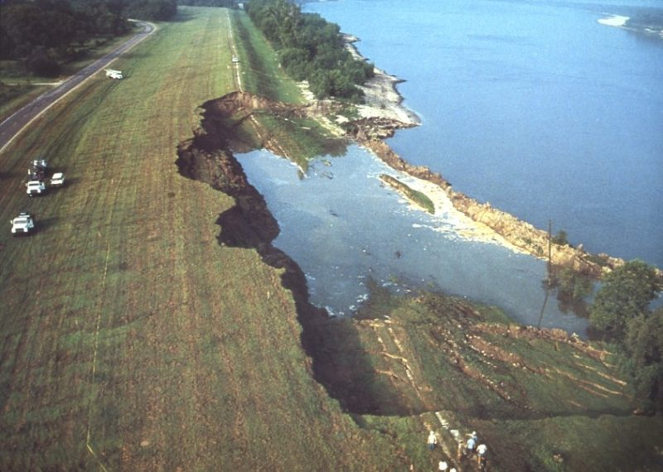 | 3 | Dam unexpectedly and without warning begins to fail. | Initiate downstream evacuation. Mobilize all available equipment and personnel to attempt temporary containment with emergency berms or ring dikes. Begin emergency lowering of the reservoir if possible. | Dozers, evacuators, dump trucks, sandbags, earthfill, plastic sheeting, filter cloth, pumps, lighting, generators | Location and size of breach, flow rate, actions taken and resources deployed, photos and videos documenting progression.

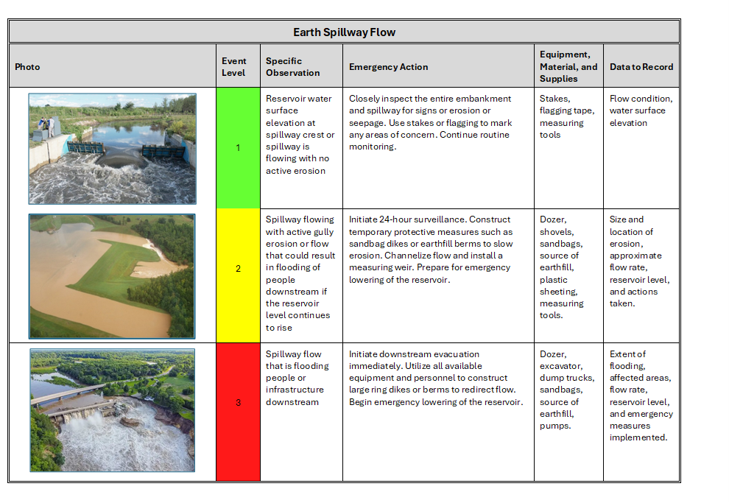

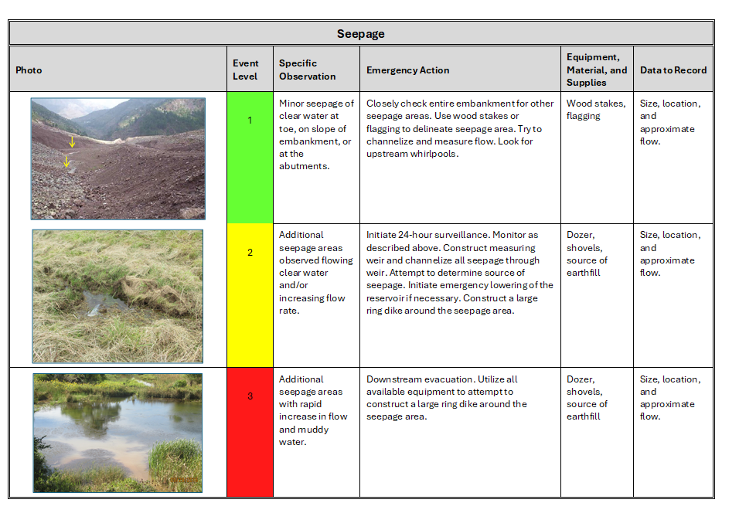

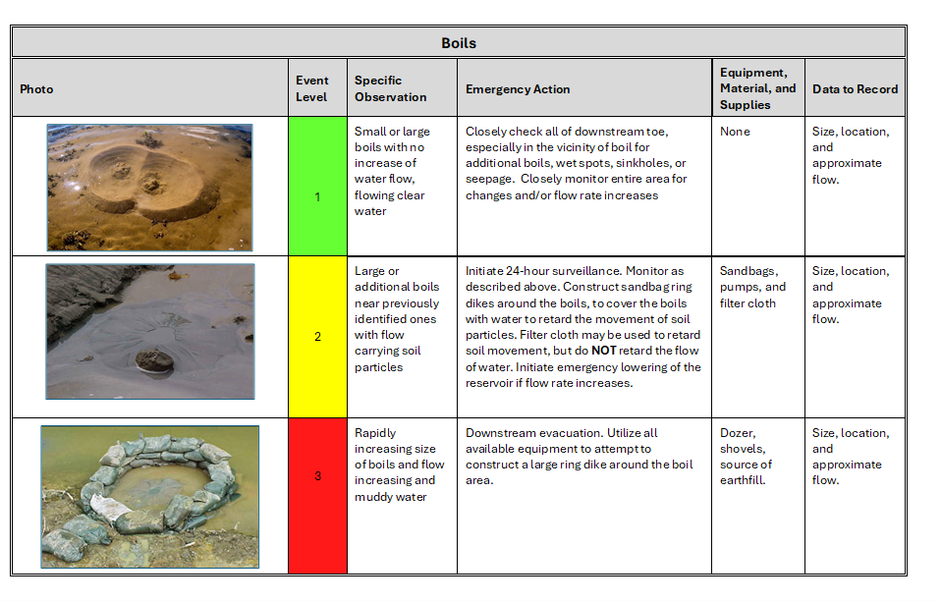

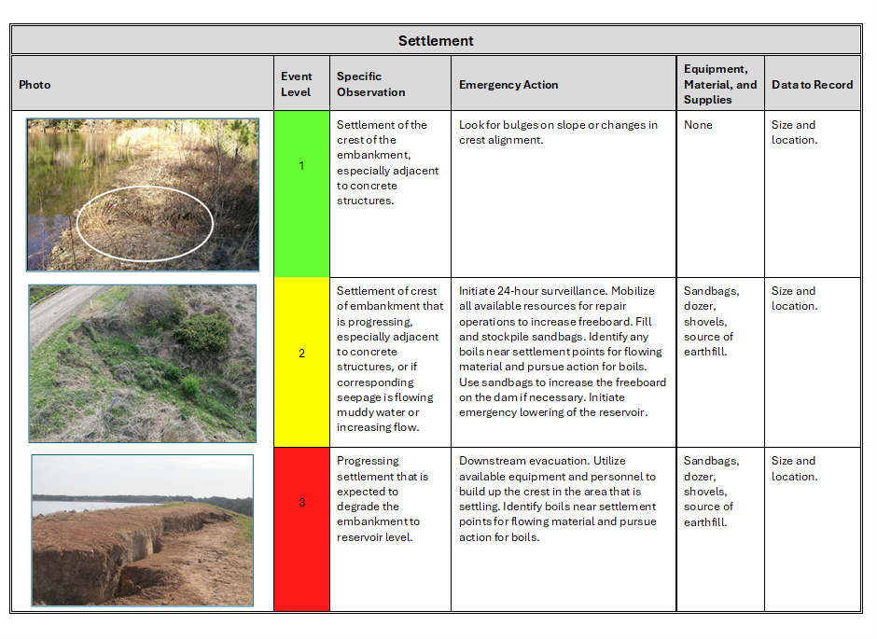

Cracking
Photo | Event Level | Specific Observation | Emergency Action | Equipment, Material, and Supplies | Data to Record
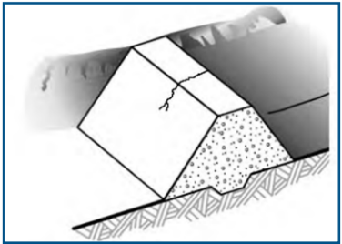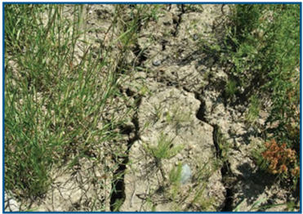 | 1 | Cracks in the embankment crest or on slopes. | Walk along entire crest and slope and check for additional cracking. | Stakes, tape measure | Size and location.
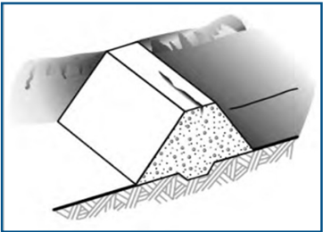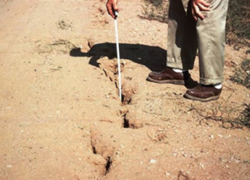 | 2 | Numerous cracks in crest that are enlarging, especially those perpendicular to the centerline of the dam. | Initiate 24-hour surveillance. Carefully monitor and measure cracking to determine the speed and extent of the problem. Mobilize to fill cracks. Cracks parallel to the centerline indicate a slide. Follow remedial action for slides. Initiate emergency lowering of the reservoir if cracks being rapidly enlarging. | Stakes, tape measure, dozer, shovels, source of earthfill. | Size and location.
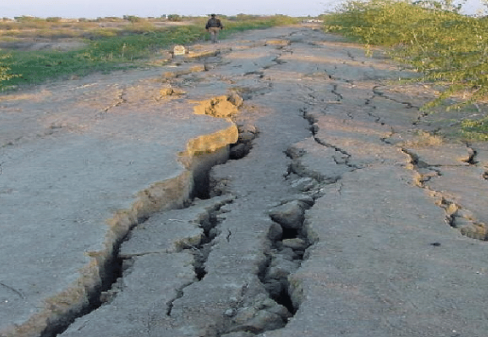 | 3 | Cracking that extends to pool elevation. | Downstream evacuation. Continue remedial actions as described above. | Dozer, shovels, source of earthfill. | Size and location.

Slides or Severe Erosion
Photo | Event Level | Specific Observation | Emergency Action | Equipment, Material, and Supplies | Data to Record
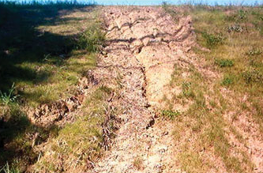 | 1 | Skin slide or slough on slope of embankment. No further movement of slide and embankment crest not degraded. | Examine rest of embankment for other slides. Place stakes in slide material and adjacent to it for determining if further movement is taking place. | Stakes, tape measure | Distance between stakes and distance to edge of slide.
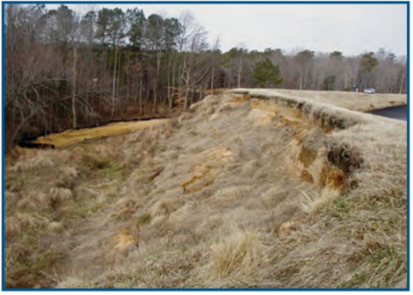 | 2 | Slide or erosion involving large mass of material, crest of embankment is degraded, size is increasing either slowly or rapidly. | Initiate 24-hour surveillance. Mobilize all available resources and equipment for repair operations to increase freeboard and to protect the exposed embankment material. Place additional material at the toe of the slope to stop the slide. | Dozer, shovels, source of earthfill, sandbags, pump. | Distance between stakes and distance to edge of slide.
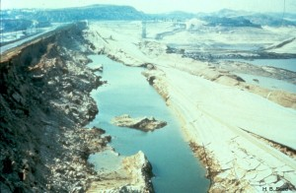 | 3 | Slide or erosion involving large mass of material, crest of embankment is severely degraded, movement of slide is continuing and may reach pool level. | Downstream evacuation. Utilize all available equipment and personnel to sandbag the degraded slide area to prevent it from overtopping. | Dozer, shovels, sandbags, pump. | Distance between stakes and distance to edge of slide.

Sinkholes
Photo | Event Level | Specific Observation | Emergency Action | Equipment, Material, and Supplies | Data to Record
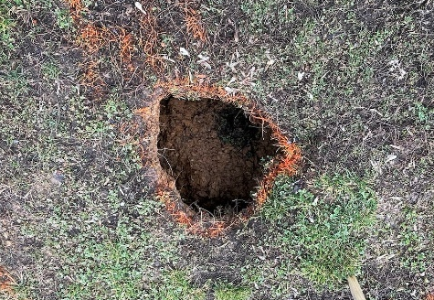 | 1 | Sinkholes anywhere on the embankment or within 500 feet downstream from the toe. | Carefully walk the entire embankment and downstream area looking for additional sinkholes, movement, or seepage. | Stakes, flagging | Size and location
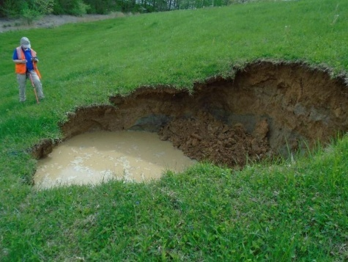 | 2 | Sinkholes with corresponding seepage anywhere on the embankment or downstream from the toe. | Initiate 24-hour surveillance. Monitor as above. Construct sandbag dike around the seepage exit point to reduce the flow rate. Utilize sandbags to increase the freeboard on the dam if necessary. | Dozer, shovels, pump, sandbags | Size, location, and approximate flow.
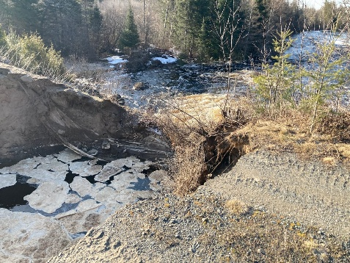 | 3 | Sinkholes rapidly getting worse, seepage flowing muddy water and increasing flow. | Downstream evacuation. Utilize all available equipment and personnel to attempt to construct a large ring dike around the area. | Dozer, shovels, pump | Size, location, and approximate flow.

Cracking or Movement of Concrete Structure
Photo | Event Level | Specific Observation | Emergency Action | Equipment, Material, and Supplies | Data to Record
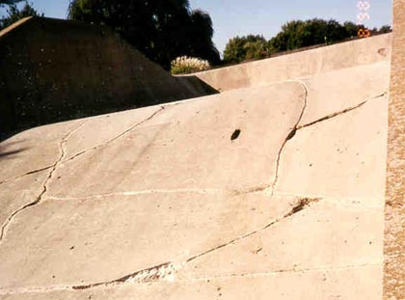 | 1 | Minor cracking and/or movement. | Immediately install measuring device to monitor movement. Mark extents of cracks with stakes to monitor progression. | Crack Monitors, stakes, tape measure. | Size, location, and movement amount.
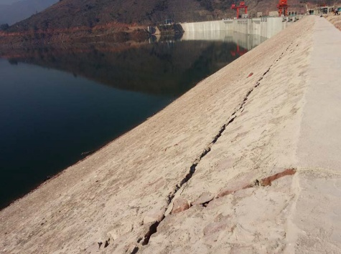 | 2 | Significant cracking and/or movement. | Initiate 24-hour surveillance. Place material on upstream face of crack to reduce flow of soil particles. Dump rockfill downstream of moving concrete structure monolith to resist the movement. Initiate emergency lowering of the reservoir. | Burlap, rockfill, dozer, shovels, crack monitors. | Size, location, and movement amount.
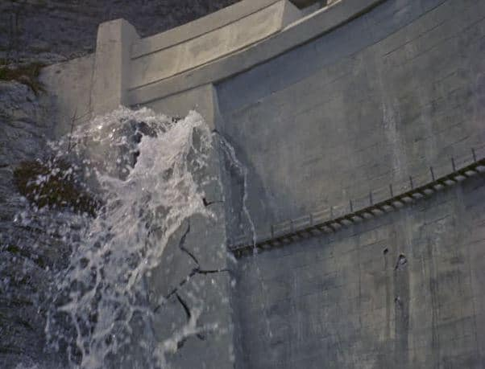 | 3 | Major cracking and/or movement | Downstream evacuation. Continue monitoring and remedial actions as described above. | Dozer, shovels, rockfill | Size, location, and movement amount.

Embankment Overtopping
Photo | Event Level | Specific Observation | Emergency Action | Equipment, Material, and Supplies | Data to Record
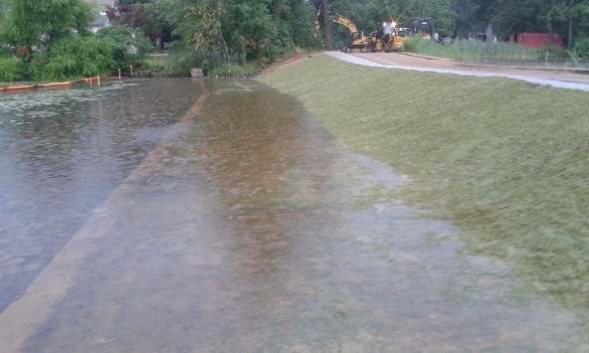 | 1  1 | Water level is within 2-3 feet of the top of dam and continuing to rise. | Begin continuous monitoring of water level and downstream slope. Prepare emergency lowering of the reservoir and mobilize resources for crest protection. | Sandbags, plastic sheeting, stakes, measuring tools | Reservoir level, rate of rise, time of observation, and any changes in downstream slope condition.
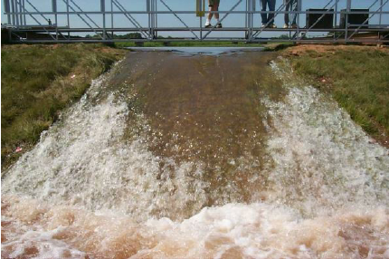 | 2  2 | Water is overtopping the embankment. | Initiate emergency lowering of the reservoir immediately. Initiate 24-hour surveillance of downstream slope of dam and begin placing sandbags or earthfill to increase freeboard and reduce erosion. | Earthfill, sandbags, plastic sheeting, dozer | Amount by which dam is overtopped, duration of overtopping, amount of erosion occurring.
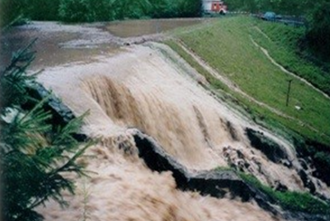 | 3 | Water from the reservoir is flowing over the top of the dam with erosion observed | Initiate downstream evacuation immediately. Utilize all available equipment and personnel to construct emergency berms or ring dikes and continue emergency lowering of the reservoir. | Dozers, excavators, dump trucks, sandbags, earthfill, plastic sheeting, pumps | Extent of erosion, breach dimensions, reservoir level, flow rate, and actions taken.

Upstream Whirlpool
Photo | Event Level | Specific Observation | Emergency Action | Equipment, Material, and Supplies | Data to Record
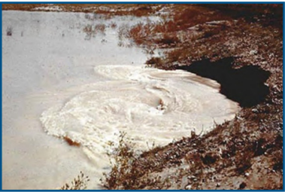 | 2 | Whirlpool in the reservoir in the vicinity of the embankment | Downstream evacuation. Attempt to plug the entrance of the whirlpool with riprap from the slope of the embankment. Search downstream for an exit point and construct a ring dike to retard the flow of soil particles. | Dozer, source of earthfill, sandbags, filter cloth, straw, rocks | Size, location, flow rate.

Severe Storms
Event Level | Specific Observation | Emergency Action | Equipment, Material, and Supplies | Data to Record
1 | Presence of storm with significant rainfall and/or high winds in vicinity of dam. | Visually inspect dam for signs of damage from high wind induced wave action or the presence of debris on or near dam. | None | Site and location. Date of storm.
2 | Indication of damage from erosion or significant erosion, or damage to dam structure or operation due to debris. | 24-hour surveillance. Continue monitoring and remedial action as described above. Initiate emergency lowering of the reservoir. | Crane or heavy equipment to remove debris; rebar for emergency repair to dam | Site and location. Date of storm. Note any issues.
3 | Erosion is significant and may lead to breach. | Downstream evacuation. Continue monitoring and remedial actions as described above. | Dozer, shovels, source of earthfill. | Note any issues.

Earthquake
Event Level | Specific Observation | Emergency Action | Equipment, Material, and Supplies | Data to Record
1 | 4.0 magnitude or greater earthquake reported within 25 miles of the dam. | Conduct a thorough visual inspection of the dam and appurtenant structures for signs of cracking, settlement, or movement. Increase monitoring frequency and verify instrumentation readings. | Stakes, tape measure, crack monitors, cameras, inspection tools | Earthquake magnitude, distance from dam, time of event, inspection results, and any observed changes.
2 | Earthquake resulting in visible damage to the dam or appurtenances | Initiate 24-hour surveillance of damaged areas. Install crack monitors and mark extents of damage. Place material on upstream face to reduce soil particle movement and dump rockfill downstream to resist movement. Prepare for emergency lowering of the reservoir. | Crack monitors, stakes, tape measure, burlap, rockfill, dozer, shovels | Size and location of cracks or damage, movement measurements, reservoir level, and actions taken.
3 | Earthquake resulting in uncontrolled release of water from the dam | Initiate immediate downstream evacuation. Continue monitoring and implement all possible remedial actions to slow breach progression while lowering the reservoir. | Dozers, excavators, dump trucks, rockfill, sandbags, pumps, emergency lighting. | Breach size and location, rate of water release, reservoir level, actions taken, and photographic documentation.

Abnormal Instrument Readings
Event Level | Specific Observation | Emergency Action | Equipment, Material, and Supplies | Data to Record
1 | Abnormal instrumentation readings beyond predetermined values. | Verify the accuracy of the readings by checking the instrument calibration and comparing with backup instruments. Conduct a detailed inspection of the dam and appurtenant structures for any signs of distress such as seepage, cracking, or settlement. Increase monitoring frequency and notify dam safety personnel. | Calibration tools, backup instruments, crack monitors, stakes, tape measure, cameras, and inspection tools. | Type of instrument, abnormal readings, time of occurrence, calibration results, inspection findings, and any corrective actions taken.

Rapidly Rising Reservoir Level
Event Level | Specific Observation | Emergency Action | Equipment, Material, and Supplies | Data to Record
2 | Reservoir level rising and rain continuing | Initiate emergency lowering of the reservoir. Initiate 24-hour surveillance of lake level and rainfall. | None | Water level, rainfall

Tab 5 – Resources and Documentation

Resources and Documentation:

Equipment and Supplies
The following equipment and supplies may be necessary and may be available for use during a dam emergency. Contact information for local contractors that can be contacted to provide equipment and support during are provided in the following table.
EQUIPMENT | LOCATION / SOURCE
Earth-moving equipment:  - Backhoes  - Dump trucks  - Bulldozers  - Excavators  - Loaders  Portable Welding Equipment  Generators  Lights  Pumps | [Company Name]  [Address]  [Phone Number]
Cranes | [Company Name]  [Address]  [Phone Number]
Sandbags | [Company Name]  [Address]  [Phone Number]
Rock Riprap | [Company Name]  [Address]  [Phone Number]
General Contractor(s) | [Company Name]  [Address]  [Phone Number]
Note: National Guard assets may be requested by OHSEP in the event of an emergency.

Technical Reference Data
In the event of an abnormal occurrence, inspection reports with photographs can be beneficial in the evaluation of a potential problem. Technical records, including but not limited to those listed below, can be helpful for comparison to current observations. Alternate personnel should be familiar with the location of the documents in the event of an emergency situation.
- Hydrology and Hydraulics Memorandum summarizing the analyses performed and assumptions to evaluate the dam breach inundation boundaries and develop the dam breach inundation maps. Include computer programs used, versions, etc.
- Reservoir Area – Capacity Curve
- Principal Spillway Rating Curve
- Emergency Spillway (Top of Dam) Rating Curve
- Annotated Site Pictures
- Plan View of the Dam
- As-Built and/or Survey Drawings

Emergency Activity Log
Any unusual or emergency condition should be documented, including the following:
- activation or deactivation of emergency facilities
- emergency notifications to other local governments and to state and federal agencies
- significant changes in the emergency
- major commitments of resources or requests for additional resources from
external sources
- telephone calls should be recorded in chronological order
- issuance of protective action recommendations to the public
- evacuations
- casualties
- termination of the incident

Emergency Costs
For major emergencies, it is recommended the Dam Owner maintain detailed records of costs expended. Documented costs may include:
- personnel costs, especially overtime
- equipment operation
- equipment leasing and rental
- contract services to support emergency operations
- specialized supplies expended in emergency operations

Tab 6 – Forms and Records
Event Log
Situation Report
Contact Checklist
EAP Evaluation Checklist
Tabletop Exercise Record
Log Sheet of Changes
Gate Opening and Closing Plan (if applicable)

Event Log
(to be completed during the emergency)
Dam name: [Dam Name] Dam Parish: [Parish Name] Parish
Water Level Elevation: Freeboard:
When and how was the event detected?

Weather conditions:

General description of the emergency situation:

Emergency level determination: Made by:
Actions and Event Progression
Date | Time | Action/event progression | Taken by
Report prepared by: Date:

Situation Report
(to be completed following the termination of the emergency)
Dam name: [Dam Name] Dam
National Inventory of Dams (NID) No.: [LA#####]
Dam location: [City], LA
(City) (Parish) (Stream/River)
Date: Time:
Weather conditions:
General description of emergency situation:

Area(s) of dam affected:

Extent of dam damage:
Possible cause(s):
Effect on dam’s operation:
Initial reservoir elevation: Time:
Maximum reservoir elevation: Time:
Final reservoir elevation: Time:
Description of area flooded downstream/damages/injuries/loss of life:

Other data and comments:
Observer’s name and telephone number:
Report prepared by: Date:

Contact Checklist
[Dam Name] Dam
[Parish Name] Parish, Louisiana
Date: [Date]
The following contacts should be made immediately after the emergency level is determined. The person making the contacts should initial and record the time of the call and who was notified for each contact made. See the Notification Charts for critical contact information and Emergency Services Contacts for contact information for other possible emergency services.
Emergency Level 1 | Person(s) Contacted | Time  Contacted | Contacted  By
___ Observer | ______________ | _____________ | ______________
___ Dam Owner/ Operator | ______________ | _____________ | ______________
 | ______________ | _____________ | ______________
___ LA DOTD District Administrator | ______________ | _____________ | ______________

Emergency Level 2 | Person(s) Contacted | Time  Contacted | Contacted  By
___ Observer | _____________ | ______________ | ______________
___ Dam Owner/ Operator | _____________ | ______________ | ______________
 | _____________ | ______________ | ______________
 | _____________ | ______________ | ______________
 | _____________ | ______________ | ______________
___ LA DOTD District Administrator | _____________ | ______________ | ______________
___ [Inundated Parish] Parish OHSEP | _____________ | ______________ | ______________
 | _____________ | ______________ | ______________
___ [Inundated Parish] Parish OHSEP | _____________ | ______________ | ______________
 | _____________ | ______________ | ______________

Emergency Level 3 | Person(s) Contacted | Time  Contacted | Contacted  By
___ Observer | ______________ | _____________ | ______________
___ Dam Owner/ Operator | ______________ | _____________ | ______________
 | ______________ | _____________ | ______________
 | ______________ | _____________ | ______________
 | ______________ | _____________ | ______________
___ LA DOTD District Administrator | ______________ | _____________ | ______________
 | ______________ | _____________ | ______________
___ [Inundated Parish] Parish OHSEP | ______________ | _____________ | ______________
 | ______________ | _____________ | ______________
___ [Inundated Parish] Parish OHSEP | ______________ | _____________ | ______________
 | ______________ | _____________ | ______________
___ [Inundated Parish] Parish Sheriff’s Office | ______________ | _____________ | ______________
___ [Inundated Parish] Parish Sheriff’s Office | ______________ | _____________ | ______________
___ LA DOTD Dam Safety | ______________ | _____________ | ______________

EAP Evaluation Checklist

Date of review: __________________ Reviewer(s):_________________________

Was an annual dam inspection conducted? | □ Yes  □ No | If yes, has the EAP been revised to include any signs of failures observed during the inspection? | □ Yes  □ No
Was brush clearing, animal burrow removal, or other maintenance required? | □ Yes  □ No | If yes, describe actions taken and date:
Was the outlet gate operable? | □ Yes  □ No | If no, describe actions taken and date:
Do the Notification Flowcharts require revision?  (Note that revision of the contact information will not require EAP approval; however, the revised contact information pages will need to be redistributed as a replacement pages.) | □ Yes  □ No | If yes, list the dates of the contact information revision and redistribution:
Was a tabletop exercise conducted? | □ Yes  □ No | Date conducted:
Are inspection records included in the EAP? | □ Yes  □ No
Was the EAP reviewed? | □ Yes  □ No | If yes, review date:
Were changes required to the EAP? | □ Yes  □ No | If yes, date of revised EAP approval:

Tabletop Exercise Record
Use this form to document simulated emergency exercises (either internal or with outside response agencies). File the completed form in Error! Not a valid result for table. of the EAP. Tabletop exercises with outside emergency response agencies are required to be conducted at least once every 5 years.
Type of Simulation Conducted:
Tabletop Exercise for Emergency Action Plan for [Dam Name] Dam [LAXXXXX]
Simulation Location: [Address]

Date of Exercise: [Date] Time: [Time] Facilitator: [Name]
Participant Printed Name | Organization / Title | Signature

Type of Simulation Conducted:  Indicate Emergency Type:  □ emergency water release  □ watch condition  □ possible dam failure  □ imminent dam failure  □ actual dam failure | Comments, Results of Exercise
Revisions Needed to EAP Based on Results of Exercise? □ Yes □ No | If yes, list revisions required:  See separate “Lessons Learned”

Log Sheet of Changes

The following changes have been made to the EAP and revisions have been provided to each of the individuals on the EAP Distribution List.
Date | Change Made | Issued By

[Gate Opening and Closing Plan (if applicable)]

Tab 7 – Distribution List

Distribution List for the hard copy of EAP
Entity | Name | Address

Distribution List for electronic copy of EAP

Entity | Name | Email Address

Tab 8 – EAP Preparation Guidelines and Resources
Guidelines for Owner Completion of the Emergency Action Plan (EAP) (Template)

- This Emergency Action Plan (EAP) template is intended for use for Significant and High Hazard dams and reservoirs, both for existing dams and new construction. For more information on size and hazard classification, please refer to the Louisiana Administrative Code Title 56 Public Works, Part III Flood Control and Water Management, Subpart 1 Water Resources and Flood Control, Chapter 7 Dam Safety Program (LAC 56:III.1.7) (ADD LINK FOR LAC).
- The Dam Owner is required to replace all red text with the appropriate information. Once the document is final, please change red text to black text.
- A table of websites for pertinent contacts follows these guidelines. Use this resource to fill out contact information in the notification flowcharts. Contact each entity to ensure contacts are current.
- All parishes identified by the breach inundation analysis as being impacted by a dam failure must be represented in the EAP notification flowchart. This template assumes two affected parishes and may be adjusted as necessary.
- Emergency Action Plans are required to be submitted to LA DOTD for all Significant and High Hazard dams, including existing structures, new constructions, and proposed modifications. The applicant is responsible for determining the dam’s hazard classification through a breach analysis and inundation mapping. All dams are presumed to have High Hazard potential unless a documented analysis, signed and sealed by a Professional Engineer, currently licensed in Louisiana, demonstrates otherwise. An EAP must be submitted to LA DOTD as a component of the maintenance and operating procedures. Owners are responsible for maintaining up-to-date EAPs and ensuring their implementation in the event of an emergency. EAPs should be exercised using a “Tabletop” exercise at least once every five years. Immediately following a “Tabletop” exercise, an evaluation of the EAP must be conducted with all involved parties to identify necessary modifications to the EAP.
- The tabletop exercise involves a meeting of the Dam Owner with local and state emergency management officials typically in a conference room. The exercise begins with a description of a simulated event and proceeds with discussions by the participants to evaluate the EAP and response procedures, and to resolve concerns regarding coordination and responsibilities. Any problems identified during an exercise should be included in revisions to the EAP. Records of tabletop exercises should be included for records in Tab 6 – Forms and Records.
- Revisions to the EAP must be recorded in Tab 6 - Log Sheet of Changes. The updated version must be sent to all individuals on the Distribution List.
- The breach analysis must define the inundation area (inundation map), peak flood elevations, and timing of peak flows at critical downstream locations. The inundation map should be created using engineering computer models like HEC-RAS Unsteady Model or other two-dimensional hydraulic analysis models as recommended in FEMA P-946 guidelines. The HEC-RAS software is available to anyone at no cost from the US Army Corps of Engineers at: https://www.hec.usace.army.mil/software/hec-ras/.
  - Inundation maps should include topographic and land use data for accurate flood mapping.
  - All electronic files and models must be submitted each time an updated EAP is submitted.
  - The inundation map should include inundation zones for the worst-case scenario breaching event as defined in Paragraph 725.B of the Louisiana Administrative Code Title 56, Part III, Subpart 1, Chapter 7 Dam Safety Program: The breach event will be somewhere between the "sunny day" breach and that event above which a breach of the dam does not increase hazard to downstream interests, up to the IDF for the dam. If the dam owner prefers to perform only one breach analysis rather than performing incremental analyses to discover the worst-case scenario breaching event, he may perform a breach analysis where the tail water is at the average annual elevation and the reservoir is at maximum design surcharge.
  - The 100-year flood elevations to determine structures “at risk,” may not be used.
  - The inundation map must show all impacted structures, roads, railroads, and other pertinent features (located within the inundation zone extent) and reference each on Breach Impacts at Road Crossings (Table 1).
  - Provide all supporting methodology used to develop the inundation map including: methodology used, assumptions made, modeling software used (if any), electronic files of the models, shapefiles of downstream inundation boundaries, associated inputs, date of creation, legend table, compass, topographic contours, scale size, and direction arrows.
  - To ensure effective emergency response, please provide an inundation shapefile to LA DOTD. This will enable local emergency management officials to better identify and evacuate at-risk areas downstream if necessary.
- When completed, submit EAP to DamSafetyInfo@la.gov.
- After the EAP is accepted, provide a copy to the Parish Office of Homeland Security and Emergency Preparedness. Contact information is available at the website provided on the following page.
Contact Resources
This table provides links and directions for locating contact information for key emergency agencies. Because contact details can change over time, users should verify all information through official sources before including it in the Emergency Action Plan or using it during an event.
Agency | How to Find Contact Info | Direct Link/Instructions
Parish OHSEP | Search by parish name on GOHSEP directory. | Parish OHSEP Contacts - GOHSEP | Governor's Office of Homeland Security & Emergency Preparedness
Parish Police Jury | Search: “[Parish Name] Parish Police Jury Contact”. | Use official parish website or Police Jury Association of Louisiana: Parish Government Information - Police Jury Association of Louisiana
Sheriff’s Office | Search: “[Parish Name] Parish Sheriff’s Office Contact”. | Use official parish website or Louisiana Sheriffs’ Association: Sheriffs Directory | Louisiana Sheriffs' Association
LA DOTD District Officials | Find the District Administrator, Assistant District Administrator, and Area Engineer in the directory. | DOTD Districts
LA DOTD State Dam Safety Official | Find the State Dam Safety Official on the LA DOTD Website. | Dam Safety Program Contacts
LA DOTD Public Information Officer | Find the PIO for the area of interest in the directory. | Contact DOTD

Tab 9 - Glossary of Terms
Abutment | The part of the valley side against which the dam is constructed. The left and right abutments of dams are defined with the observer looking downstream from the dam.
Appurtenances | Structures incident to or annexed to dams essential to the proper operation, maintenance or functioning of the dam. This includes such structures as spillways, low-level outlet works, and water conduits, such as tunnels, pipelines, or penstocks, either through a dam or its abutments.
Breach | An opening through the dam that allows draining of the reservoir. A controlled breach is an intentionally constructed opening. An uncontrolled breach is an unintended failure of the dam.
Control section | A usually level segment in the profile of an open channel spillway above which water in the reservoir discharges through the spillway.
Dam | An artificial barrier generally constructed across a watercourse to impound or divert water.
Emergency spillway | The appurtenant structure that provides the controlled conveyance of excess water through, over, or around the dam.
Gully | A gully is a narrow valley or channel with steep sides, often formed by running water or heavy rains
Head cut | A type of erosion that occurs when water flow causes a sudden drop in the channel bed, creating a steep, vertical face
Left | The side of the dam that is on your left when you are facing downstream, looking from the upstream side towards the downstream side.
Low-level outlet works | An appurtenant structure, usually consisting of a pipe through the embankment or principal spillway structure equipped with a valve, whose purpose is to allow lowering the lake level.
Principal spillway | The appurtenant structure that conveys normal inflow through or around the embankment.
Right | The side of the dam that is on the right when you are facing downstream, looking from the upstream side towards the downstream side
Reservoir | The body of water is impounded or potentially impounded by the dam.
Seepage | The natural movement of water through the embankment, foundation, or abutment of the dam.
Unusual Event | An event which takes place, or a condition which develops, that is not normally encountered in the routine operation of the dam and reservoir or necessitates a variation from the operating procedures.

