PROJECTED ADVERTISEMENTS
For information on how to get an advertisement processed in CCS, click on the link below: http://www.dotd.la.gov/Inside_LaDOTD/Divisions/Engineering/CCS/Pages/default.aspx
Click on PM Information for Advertisements
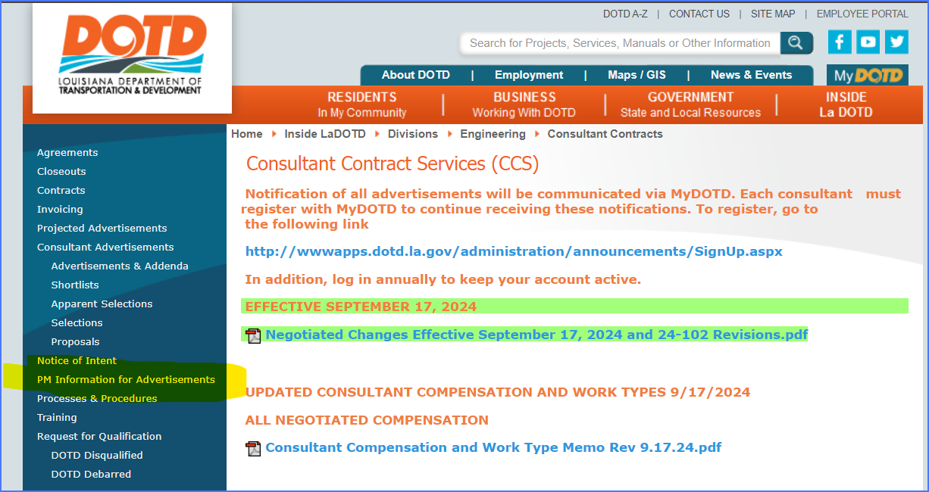
Item 1: Most important thing is to get project on the projected ads website for a minimum of 30 calendar days as soon as you think you might need a contract so you are not losing time on that process.
- Complete the Projected Advertisement Website Form and submit to DOTDCCSAdvertisements@la.gov
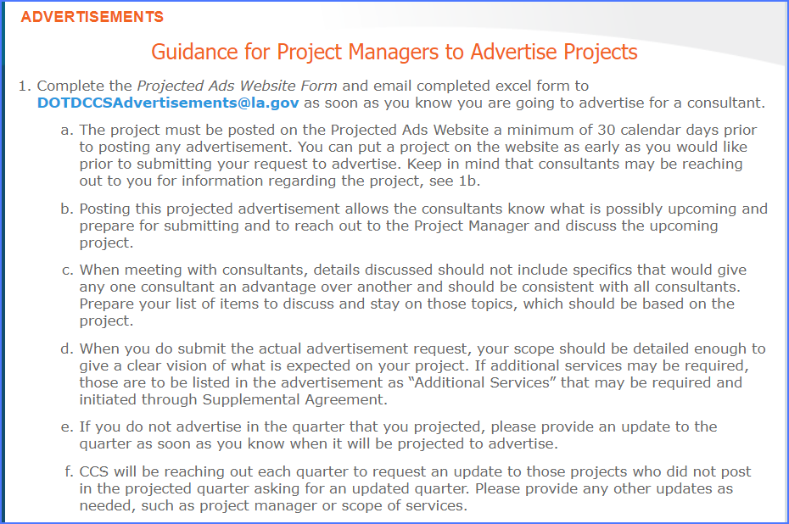
ADVERTISING
Item 2:
- Complete Request to Advertisement Request Form to provide advertisements details.
  - The Advertisement Request Outline provides useful information on completing the Advertisement Request Form correctly.
- Complete the 48 286 Request to Hire Consultant – get appropriate executive level approval (should be submitted to CCS within 30 days of signature)
- Submit the Advertisement Request Form and 48 286 Request to Hire Consultant memo along with editable scope (word document), editable minimum personnel requirements (word document) and estimated compensation to DOTDCCSAdvertisements@la.gov. To be compliant with Federal Acquisition Regulation (FAR), CCS must receive estimated compensation with estimated work hours for project specific and entity projects.
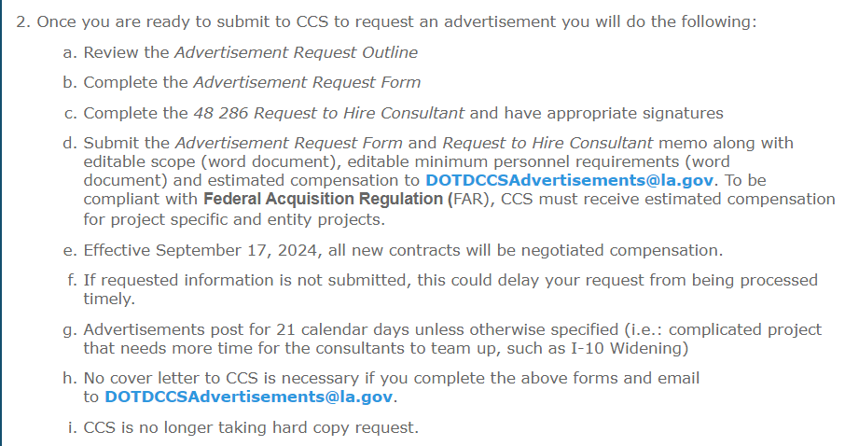
Item 3: CCS follows compensation by work type as designated by memo
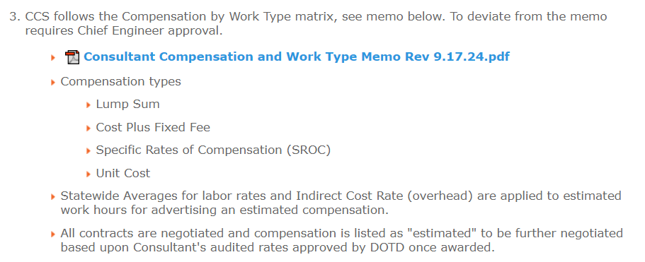
- Forms and CCS Manual are listed at the bottom of the page
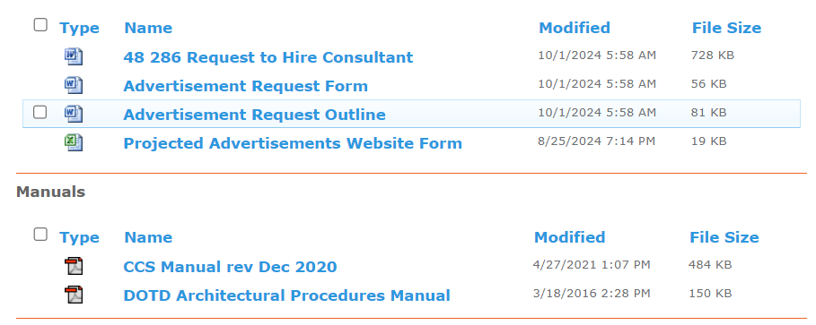
Once all information is submitted to CCS, a draft will be prepared with scope and compensation and sent to the PM for concurrence.
After concurrence, the draft will be forwarded to Compliance for a DBE Goal determination. They will review the scope and the disciplines to be used in the project, i.e., road, survey, CE&I and based on scope, disciplines and location of the project, a goal will be set.
- Exceptions for setting a DBE Goal:
  - if no sub-consultants are allowed for the contract
  - The compensation total will be less than $250,000 – then it is automatically No DBE Goal for the contract.
The draft is sent to the DBE committee with the DBE goal for concurrence.
Once DBE committee concurs, the advertisement will be posted for 21 calendar days. Exceptions are allowed but no less than 14 calendar days to post an advertisement.
After the advertisement deadline passes, CCS will conduct a non-responsive review of all proposals submitted to make sure they can all be evaluated.
- If there are any proposals deemed non-responsive, there is a protest period of 72 hours to allow consultant to protest and no proposals can be evaluated until the protest period has passed or the protest has been resolved.
NOTE: Entity held contracts require an executed Entity State Agreement (ESA) when advertising the project.
PROJECT EVALUATION TEAM
After the non-responsive reviews and clarifications are completed, the advertisement is then queued for the Project Evaluation Team to have a kickoff meeting with the Project Manager which takes approximately 30 minutes and could be scheduled via Zoom if necessary.
The Project Manager is expected to be a part of the evaluation team and evaluate the proposals. The evaluation meeting is typically 2 weeks later (currently on Thursdays) but can be adjusted if necessary. The evaluation meetings can vary from 1 to 4 hours, depending on the number of proposals and complexity of the project. The Project Manager does not have to participate but CCS encourages participation for the Project Manager’s input in the evaluation. There is no individual scoring anymore, it will be a consensus score that is determined at the evaluation meeting, with final rankings (known as the Short List) available before leaving the meeting.
The Short List is posted for 72 business hours, usually on Mondays, but 2 days after the evaluation meeting. This time allows for a consultant on the Short List to protest, if warranted.
After the protest period has passed and no protests are filed with CCS, the PM will receive an email from CCS asking for their recommendation on which firm to select. If this is an Entity contract, the Entity will also be asked for a non-binding recommendation of which firm they would like to see selected.
SELECTION
A packet is prepared for the Secretary to make his final selection with the recommendations from the PM (and Entity, if applicable) and is sent via DocuSign.
If the Secretary selects No. 1 firm on the Short List, then CCS issues an award letter to the selected consultant and notifies the consultant community via MyDOTD.
- If the Secretary selects other than No. 1 firm on the Short List, this becomes an Apparent Selection and CCS posts this Apparent Select along with a justification letter as to why he selected the firm. This is posted for 48 hours to allow for an appeal period.
- If no appeal is filed with CCS, then CCS will issue an award letter to the selected consultant and notifies the consultant community via MyDOTD.
The award letter email is copied to CCS Contracts unit via DOTDCCSRequests@la.gov to start the process of drafting the contract. The award letter informs the consultant to prepare their QA/QC plan for PM’s approval and should be sent within 10 days of receiving the award letter/email.
- The PM should review and approve the QA/QC plan and forward to CCS to include with the final executed contract.
- If the plan is not adequate, PM should work with the consultant to get a plan that is acceptable to DOTD.
This award letter is the signal for the PM to schedule a kick off meeting with the consultant to start negotiations on the specific details for the scope of services.
CONTRACT PREPARATION
The Contracts unit will assign a Reviewer to start the CCS process and the Reviewer will reach out to the PM asking for information, work-hours and approved QA/QC plan.
PM NEGOTIATIONS
The kick off meeting should start with negotiating the details of the scope to make sure PM and consultant understand the services expected for that project. Once the scope has been negotiated then the work effort (work-hours) must be applied to the agreed upon scope of services independently from the PM and from the consultant. These are the independent work-hours that will determine if DOTD and consultant are within 10% +/-. The statewide averages found on CCS website are to be applied to the labor classifications determined for the work effort. This initial comparison should identify areas that are not matching up to expectations and should be discussed and negotiated. The PM and consultant should re-submit the work-hours with statewide averages applied and see if they are within 10% +/-. Compensation total is not what is being negotiation here, the scope and work-hours are the negotiations.
Once negotiated scope and work-hours are agreed upon, if the consultant is higher than DOTD’s work-hours but within 10% +/-, then the PM should accept the consultant’s final work-hours. The consultant shall prepare a “cost proposal” where the consultant applies their labor rates and indirect cost rate (overhead) to the agreed upon work-hours. It is preferable that the consultant use the DOTD approved labor rates average per classification and the DOTD approved indirect cost rate (overhead) average.
If direct expenses are expected, those should be negotiated as well, based on rates in the current Louisiana State Travel Regulation Guide. Meals, lodging and mileage rates are to follow the current GSA rates. Quotes are required to support special items or support, such as traffic control, police support, specialty equipment rentals, etc.
The original independent work-hours from both the PM and the consultant along with the “cost proposal” shall be submitted to CCS within 90 days. Extensions can be requested seeking approval by appropriate executive-level staff member or designee.
PM PROVIDES CCS WITH NEGOTIATED SCOPE AND WORK-HOURS
The approved QA/QC plan, final negotiated scope and cost proposal should be submitted to the CCS reviewer assigned to the contract. CCS will pull these DOTD approved average rates and will use the lower of the labor rates, proposed (from the cost proposal) or audited average rate and work up the compensation first to see if the original amount requested for the advertisement has been exceeded by 1/3rd of what the Division Head approved. CCS Reviewer will notify the PM if that amount is exceeded and advise the PM to seek additional approval for more compensation to continue with the contract.
CCS Reviewer will draft the contract, scope (which should be written on DOTD’s behalf and never reference the consultant’s name, only referred to as “the consultant”) and compensation. It will be reviewed by the CCS Supervisor and then sent to the PM and consultant for concurrence.
Once concurred by both parties, the CCS Reviewer will send via DocuSign, the contract for signature along with any required legal documents. If there is a specific rates of compensation (SROC) letter (usually CE&I contracts), that will be sent out via DocuSign separately from the contract document.
CONTRACT EXECUTION
When the DocuSign contract is signed by the consultant, it is then prepared for routing with checklist and supporting documentation to the Secretary for signature through the Division Head.
The Notice of Contract Execution (NOCE) is then prepared and sent out via DocuSign to consultant, PM and other pertinent personnel. This NOCE does not give authorization for the consultant to start work.
- Project Specific contracts require a Notice to Proceed (NTP) from the PM to give the consultant authorization to start work.
  - Invoices cannot bill for work prior to the NTP date or Advanced NTP date.
- IDIQ Contract requires no Notice to Proceed (NTP) – task orders will be initiated and those will require a NTP to authorize the consultant to start work.
NOTE: All actions will be negotiated; however, task orders should be negotiated within 60 days instead of 90 days. See the link for guidance to the Project Managers http://wwwsp.dotd.la.gov/Inside_LaDOTD/Divisions/Engineering/CCS/Pages/Contracts.aspx
PM REQUEST BUDGET FOR APPROVED COMPENSATION
Notice to Proceed cannot be issued until funding is requested and authorized. Budget request should only be requested once the draft is concurred or signed so that the compensation amount is correct and matched the action with the purchase order (PO).
Once the Budget request is received, a shopping cart should be setup as indicated by the budget request. The shopping cart is usually created by an administrative assistant. The shopping cart should reference in the internal notes, the contract number, the state project number, task order number, if applicable and any special notes, such as, add to existing PO #XXX or this is a partial with more to come once funding is finalized. If possible, the NOCE/NOTOE and contract action should be attached in the Notes and Attachment field for easy verification of contract and amount. Once submitted, the shopping cart goes to CCS for approval and processing.
The shopping cart comes in to the work overview for CCS, it is verified as to contract no., task order no. and contract amount to see if they match. If they match, the shopping cart is approved and forward to the CCS purchasing group who will flip into a new purchase order or add the shopping cart to an existing PO per instructions from the shopping cart creator. The CCS reviewer will email the PO to the consultant, PM and any other pertinent personnel.
NOTICE TO PROCEED
The Notice to Proceed can be issued once the PO has been created. The PM must include CCS via DOTDCCSRequests@la.gov when issuing the NTP so we can update and file the NTP in the appropriate databases (currently Lotus Notes and FileNet) for invoicing and auditing purposes.
SUPPLEMENTAL AGREEMENTS AND EXTRA WORK LETTERS
A supplemental agreement to a contract or extra work letter may be executed when it is necessary to add compensation for ancillary services required for the project. Ancillary services are services that are within the general scope of the advertised project but were not obvious components of the project immediately identifiable at the time of contract execution.

Additional compensation for ancillary services is limited to 75 percent of the original contract maximum compensation for contracts entered into on July 1, 2009, or thereafter. Negotiations for supplements agreements and extra work letters are limited to 60 days.

Complete the forms and submit to CCS once negotiations have been completed to DOTD
TASK ORDERS AND SUPPLEMENTS TO TASK ORDERS
A supplement to an existing task order should only be executed in other special and rare circumstances and must have Division Head approval.

INVOICING
The next step for PMs will be getting DOTD standard invoices from consultant, which must be submitted monthly and timely. The link below will bring you to the CCS invoicing website which will provide useful information.
http://wwwsp.dotd.la.gov/Inside_LaDOTD/Divisions/Engineering/CCS/Pages/Invoicing.aspx
The consultant must use the DOTD Standard Invoice for all invoices. Any invoices that do not use the DOTD standard invoice format, does not have all required supporting documentation, is incomplete or is invoicing for work prior to the NTP date will be returned to the PM with a notation as to why it is being returned. If no work was performed during a month, then that invoice should be a zero invoice and uploaded in the I-Tracker, keeping the monthly flow for tracking on the contract.
In accordance with the contract, all invoices must include the DBE Form 1 regardless of the DBE goal. Include a PO Overview, which shows that the PO has money and which lines have money available. A progress report shall be submitted except in phase 6 services.
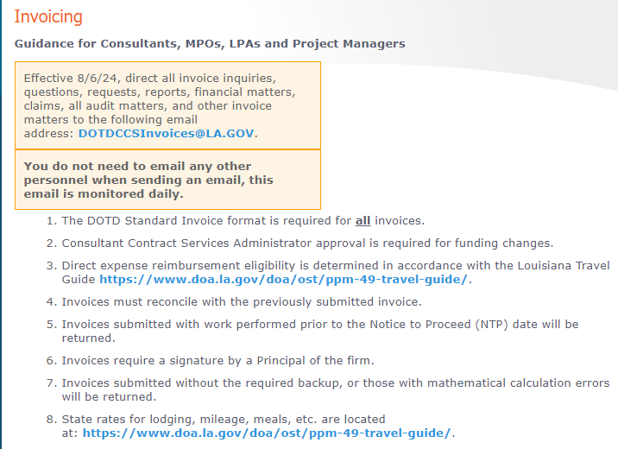
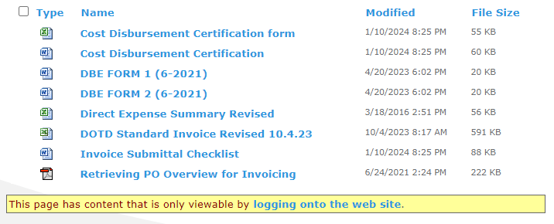
The PM shall review the invoice, verify it for accuracy and correctness, sign in appropriate places to verify that it was approved by the PM and should be uploaded into the I-Tracker, which is the CCS portal to process invoices.
PM will click on the blue link “logging onto the web site”, scroll to the bottom of the page, which has Tips for Project Managers when Submitting Invoices.
Click on the blue link “CCS Invoice Processing Tracker Application” to open up the portal to upload invoices.
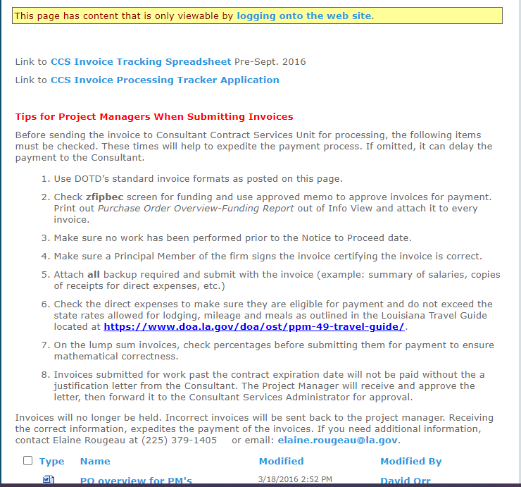
PM/TM will need permission for access in order to upload to the I-Tracker. This permission can be requested through DOTDCCSInvoices@la.gov along with personnel number.
This is what the I-Tracker looks like, click on New Invoice button and start entering information
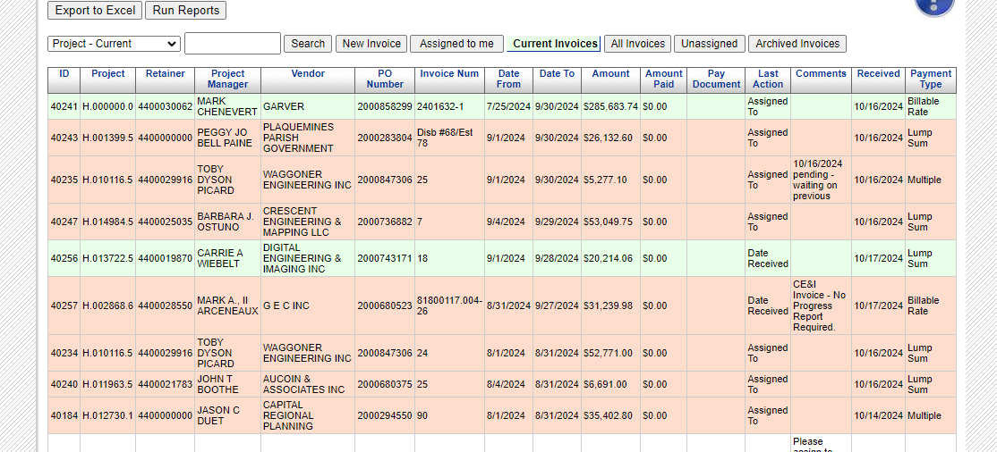
Here is the new record, complete all required fields, DBE Goal % and payment type.
- Cost DISB and Cost REIMB is for Entity-held invoices
- If you have different payment types in your invoice select “Multiple” (i.e., billable and lump sum)
- If you have only one payment type then select appropriate type (only cost plus)
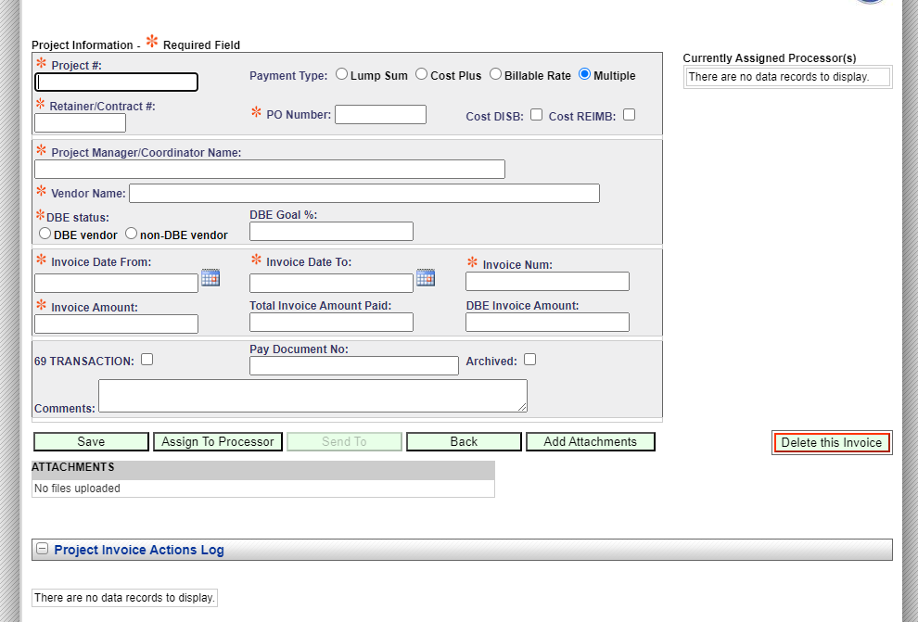
A completed record from the Project Manager/Task Manager is shown below.
Upload the invoice under the Attachments field. The invoice must include all items requested by CCS, otherwise, the invoice may be returned to PM/submitter or CCS may reach out to PM to get missing information. If information is not provided within 3 business days, the invoice will be returned to PM/submitter.
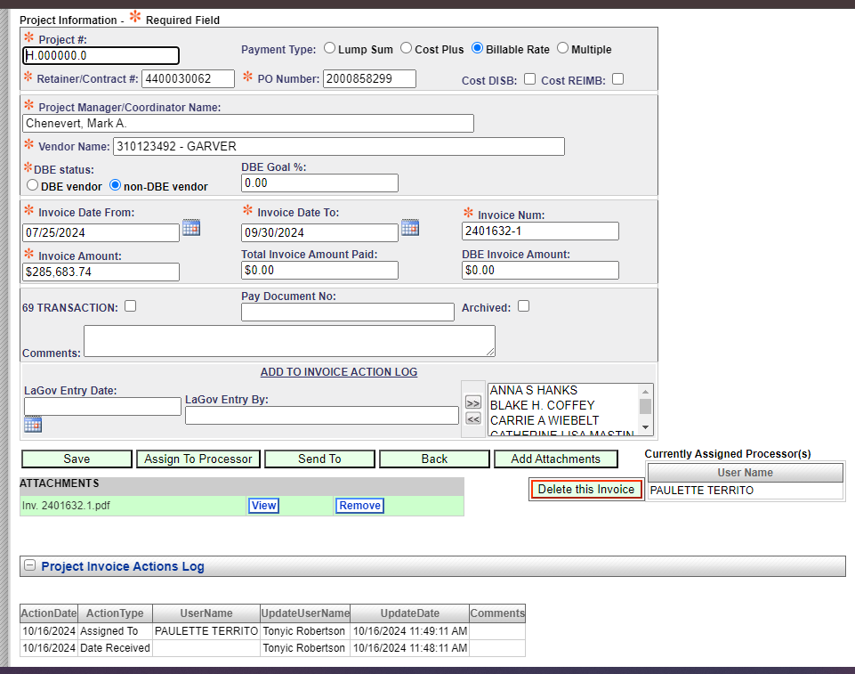
CCS Invoicing will back check the invoice to make sure that there is no billing outside of the contract terms, match specific rates of compensation to SROC letter, check the direct expenses to make sure they are in accordance with the Louisiana Travel Regulations, verify time and mileage against time sheets, etc.
If there are items that exceed limits or items that are not allowed, the invoice will be marked up and adjusted. A copy will be sent to the PM and the PM will need to send the consultant a copy so they can make adjustments for the following invoices so that the carry forward amounts will match.
Once the invoice is ready for payment, CCS will enter the payment information against the PO into LaGov ECC module, which will put the invoice in a queue for Financial Services to make the actual payment.
CLOSEOUTS (OF PURCHASE ORDERS)
When a project specific contract or task order is ready to closeout the PO in CCS, which will be releasing the funding if any and more importantly closing the loop on the contract action in CCS, the PM should submit the appropriate closeout letter, which can be found at the link below:
http://www.dotd.la.gov/Inside_LaDOTD/Divisions/Engineering/CCS/Pages/Closeouts.aspx
It has guidance on what CCS needs in order to close out your PO and release any funding back to the budget. It effectively closes the contract action that was generated with CCS, it does not do any closures in LaGov, other than the PO or in PS, such as, putting the project in TECO status or notifying Budget to close out a phase. This must be done separately when applicable.
When submitting the Notice of Completion letter to closeout a contract action, include the PO Overview which shows the remaining funds, if any. Even if no funds are left on the PO, CCS will go into that PO and shut down the PO and label it as “CLOSED”. Also required, is one Consultant Past Performance Evaluation (CPPE) showing that the Consultant was rated for past performance. (Exception to CPPE is Entity held contracts - no CPPE is done for these contracts)
The final invoice must be paid prior to submitting the Notice of Completion letter, except for the actual IDIQ contract; however, all individual task orders must be closed out before or with the IDIQ contract. CCS will email the submitter with the final details of the closeout.
All closeout request and questions are directed to DOTDCCSCloseouts@la.gov .
