**How to Change a Project’s Spec Book**

The process to change a project’s spec book requires that the project not be assigned to a proposal.

Any cost estimates, or records associated with cost estimates in the project, are also copied and updated with the new spec book. Those records included in the copy process and updated with the new spec book items include the following:

* task groups,
* reference price tasks,
* bid-based tasks,
* cost sheet tasks,
* cost estimate item bid based task bid history profiles,
* contingency assignment profiles,
* typical section profiles,
* life cycle maintenance schedule profiles,
* maintenance milestone items.

**Step 1 – Create a copy of the project.**

1. From the Preconstruction menu, click the **Projects** link.

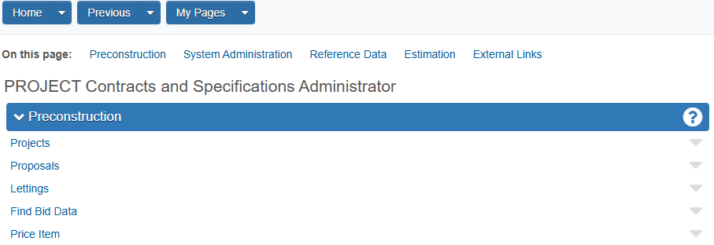

1. Under *Project Overview*, locate the project whose spec book you want to change. Click the row Actions menu.

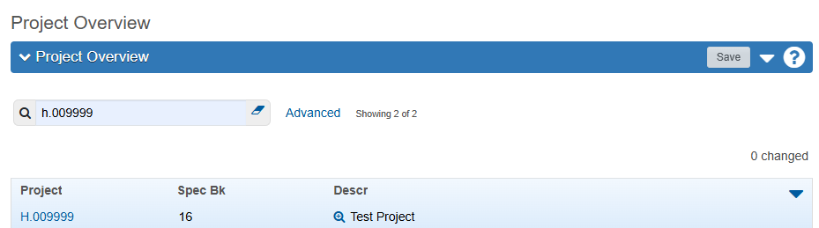

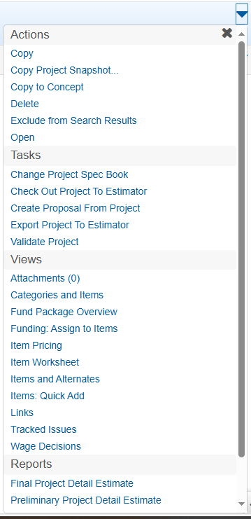

Select **Change Project Spec Book** from the **ACTIONS** menu.

**Step 2 – Rename the source project and select new spec book.**

1. Click in the **Source Project ID** field, and type a unique ID that will be used to rename the source project (the project you want to rename).
2. Click in the **Destination Spec Book** field, and type the name of the new spec book you want to assign to the project.
3. Click **Save**.

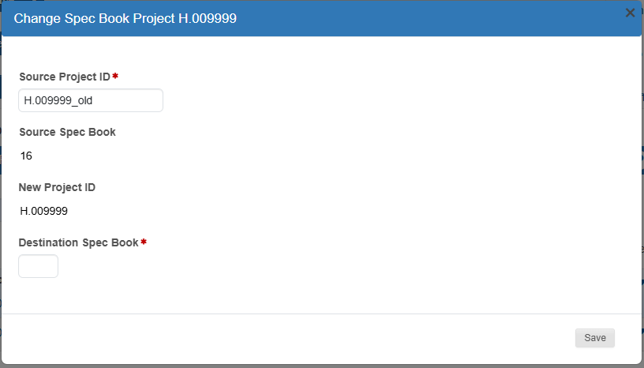

26

**Step 3 – Update the items in the new project.**

1. No longer included in the project and associated cost estimates are:

* Items that were obsoleted or deleted from the new spec book;
* Items missing a supplemental description required by the new spec book

If an item does not transfer to the new project., the below warning message will display, and a .txt file is created identifying such item(s).

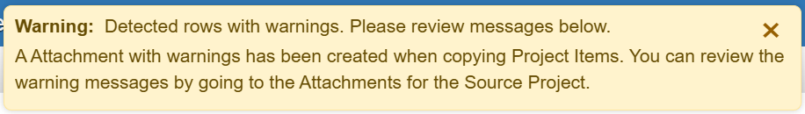

**IMPORTANT**: It is highly recommended to double-check all items in the event that some items may not have been captured in the exclusion reports.

1. Click the *Project Overview* component and locate the source project (H.009999_old).

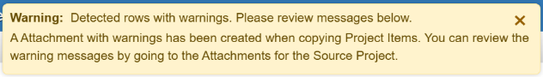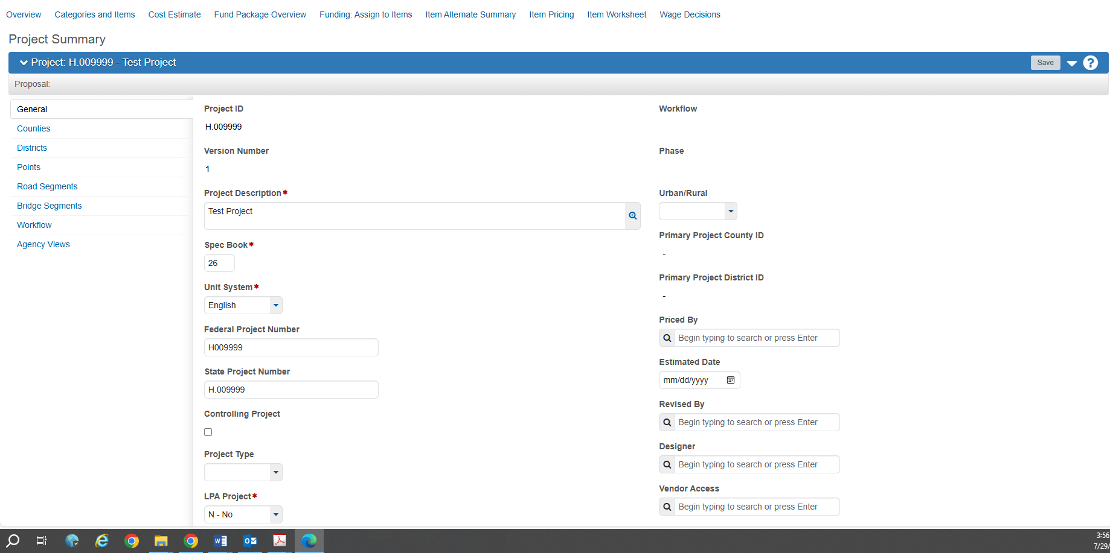

**Project Summary** page for new spec book with warning message.

Click **Overview.**

1. Click the **Actions** menu in the source project row, then click **Attachments**.
2. Locate the **ProjectItemsNotCopied.txt** or **EstimationItemsNotCopied.txt file**.

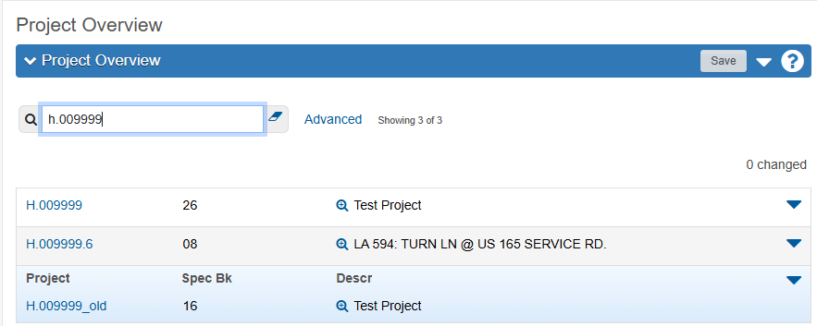

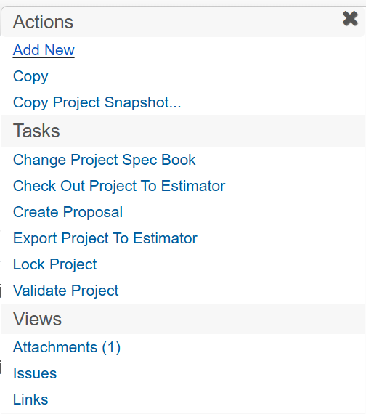

Project Summary **ACTIONS** menu. Click *Attachments.*

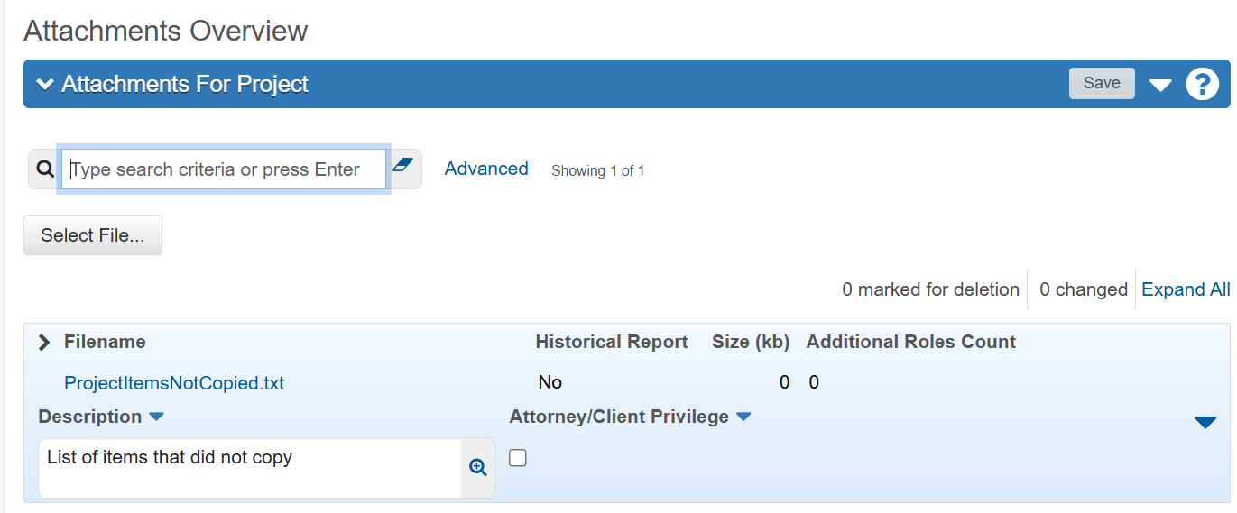

1. This file identifies the items that failed to transfer by their line number of the source project. This will help you determine what changes, if any need to be made to your 2026 project.

